2. Develop a Java program to create a class Book with members Book ID, Title, Author, and Price. Use a constructor to initialize the details. Include methods to display book information, overload search() to search by Book ID and Title, and create a method that accepts another Book object and returns the costlier book. Use a static member to maintain the total number of books created. In the main class, create multiple book objects and demonstrate all the operations.
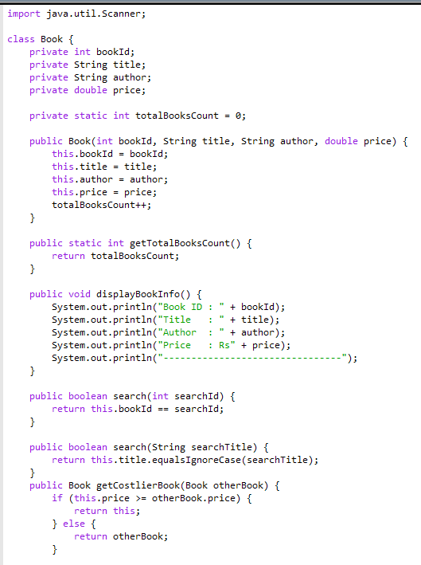
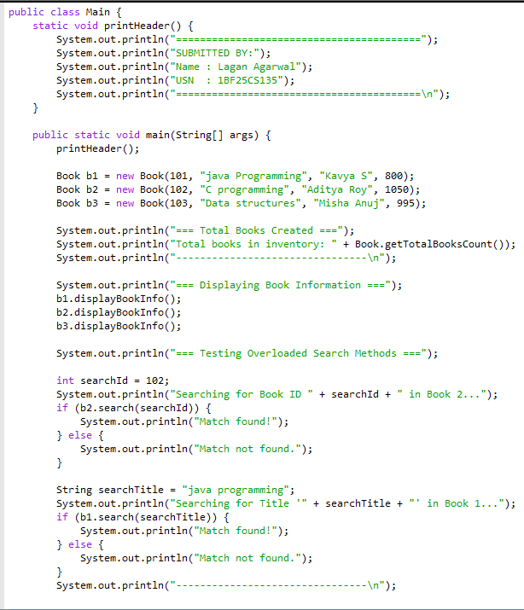
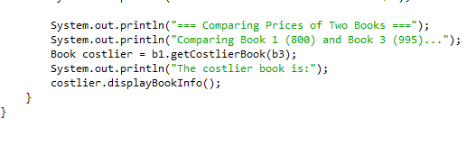

OUTPUT:


